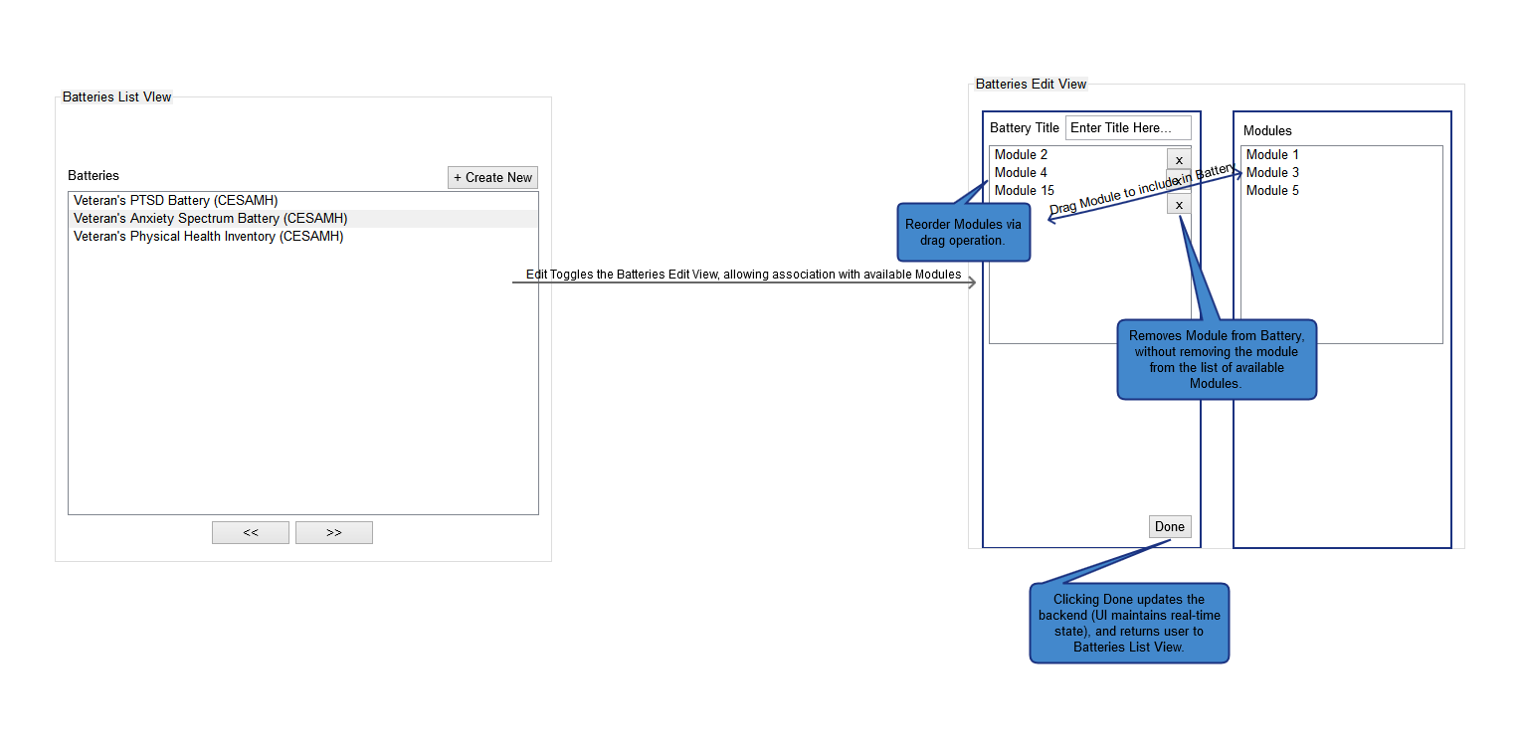

Figure 1: Battery Editor Screen

* Initial view is a list of defined Batteries viewable/selectable by the user. Selection brings up contextual button selection for entry into Edit flow. Selecting ‘Create New’ allows the user to create a new Battery. Both Edit and Create New will navigate the user to the Edit view.
* In the Edit view, the user can define Battery-specific properties (Name, at this time), and build out the Battery by drag and drop of child Modules that will compose the defined Battery at the top level.
* In the Edit flow, the User can reorder any dragged Module via a sortable drag operation. The result will change the navigational order of the Battery’s Modules for users taking the Battery when it is sent to the server.